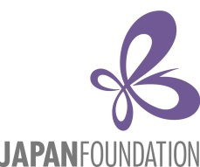

**Asian Center-Japan Foundation Study Tour 2015**

Consent Form

I, _____________________________________ (full name), (parent/legal guardian) of _______________________________________________ (name of applicant), am giving consent for him/her to travel to Japan to present a paper at the *20th Philippine Studies Forum for Young Scholars* and join the Asian Center-Japan Foundation Study Tour 2015 from July 2-7, 2015 with the following itinerary:

July 2: Arrival at Osaka

July 3: Osaka to Shizuoka, Toro Yayoi Archaeological site

July 4: Philippine Studies Forum for Young Scholars Day 1

July 5: Philippine Studies Forum for Young Scholars Day 2

July 6: Kyoto or Osaka

July 7: Departure for Manila from Osaka

Contact number/s: ____________________________________________________

E-mail address/es: _____________________________________________________

__________________________________ _________________

Signature over printed name Date